CUSTOMER USE CASE DIAGRAM

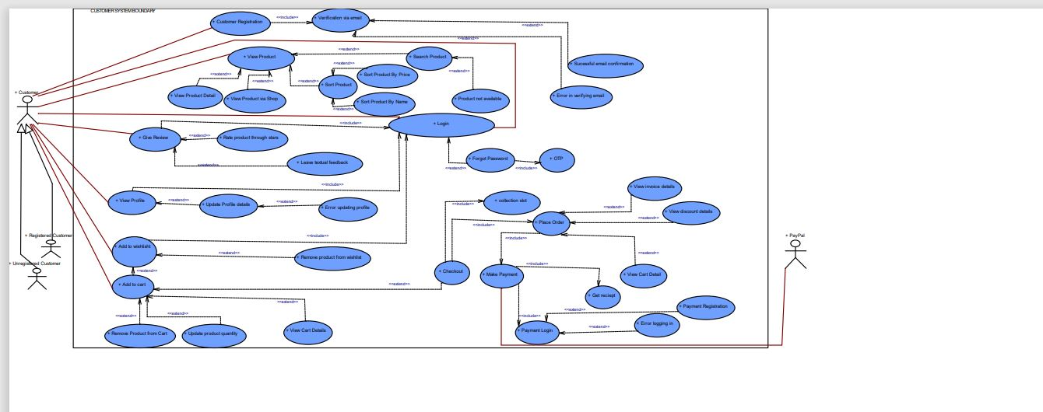

TRADER USE CASE DIAGRAM

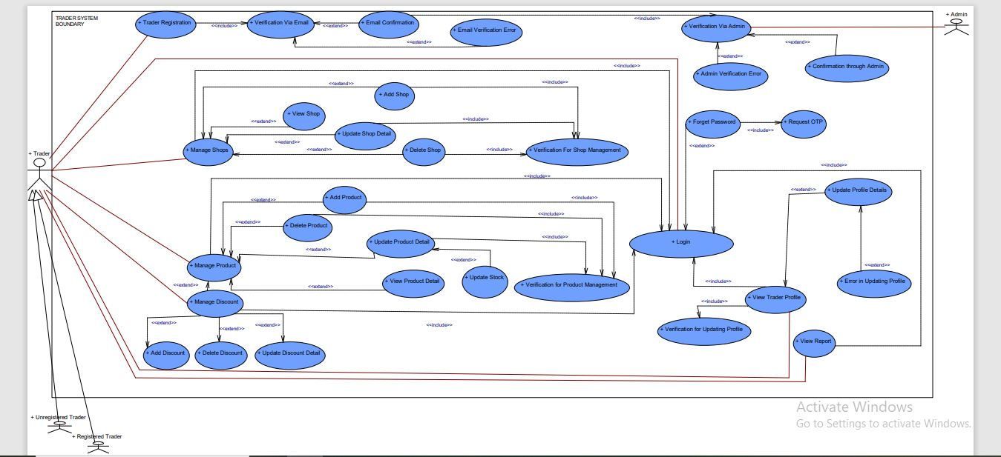

ADMIN USE CASE DIAGRAM

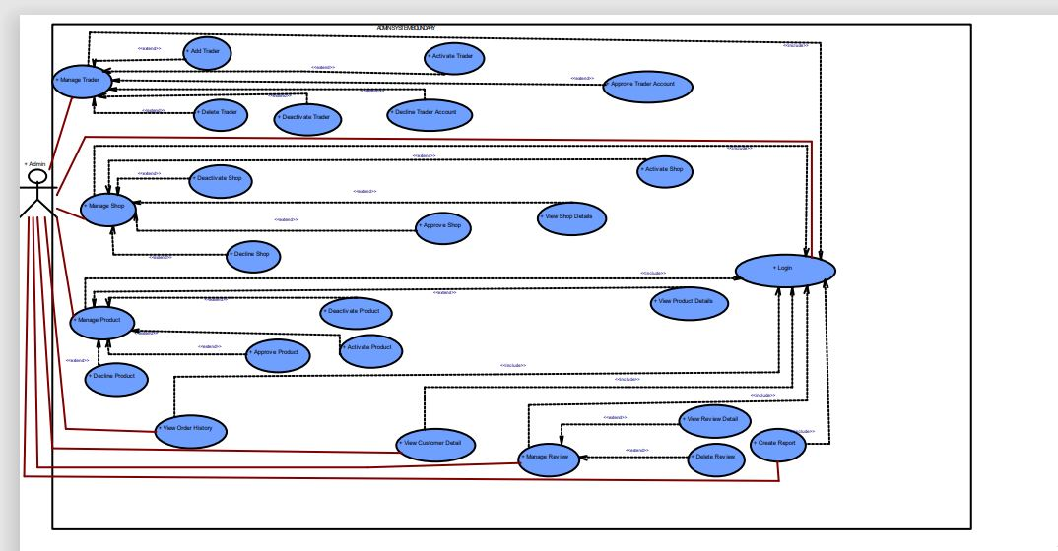

OVERVIEW USECASE DIAGRAM

